Ethan Daugherty

SNHU

CS-360-H7255

1-4 Assignment: Users and Solutions

03/06/2022

**Users and Solutions**

* Describe the design and purpose of the app you selected. Begin by looking at the app overall and think about what primary task the app has been created to help users achieve. Identify the overarching goal you believe the app was created for. Also discuss the design elements that lead you to draw this conclusion. Think about what the app looks like and how that signifies to users what the app will enable them to do.

The app I’m going to analyze this week is the Youtube App. The App allows a user to view content posted online by other users and to upload their own videos to share with a larger audience. The app will additionally load content based on your interests on other videos you have viewed. I believe this because the app is designed to show you content as soon as you open the app that you may be interested in. The App icon on its own is designed around a play button, leading users to want to play content within the app. Historically on IOS the application had been a vintage TV icon.

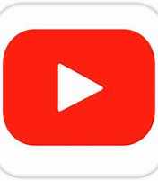 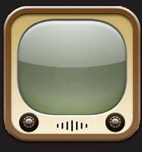

Figure 1: Current YouTube Icon Figure 2: Old YouTube App Icon

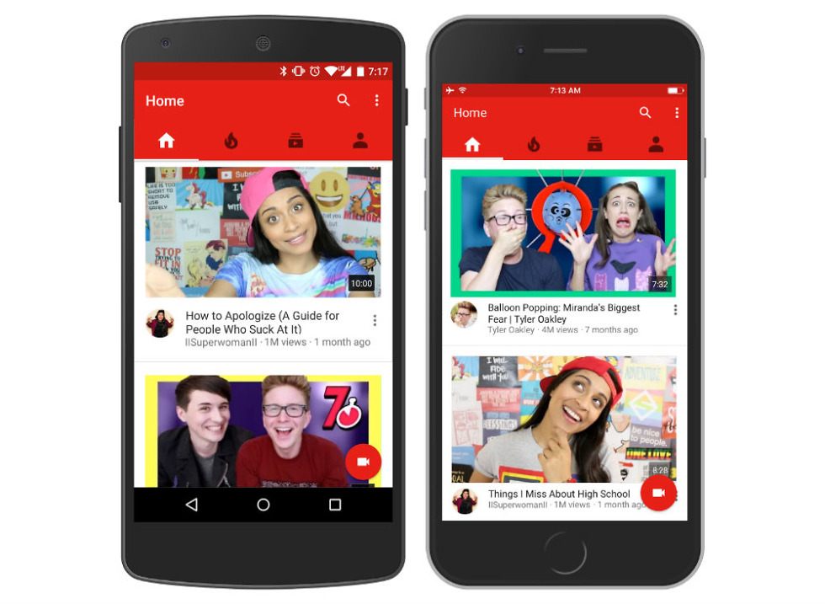

Figure 3: YouTube App Home screen

* Identify the user needs that the app is designed to address. You should identify at least three needs the app helps users address. Each app’s overall purpose, which you have already looked at, is supported by smaller tasks a user can do within the app. For example, a maps app may have the overall goal of providing location information to a user. This might be supported by how it identifies local restaurants or offers directions from one address to another via varying pathways. Think about the following questions as you craft your response:
  + What users does this app serve?
  + What might a user want to accomplish with this app?
  + How does the app support those user goals?
  + Is the app trying to persuade a user to take an action?
  + What is the app’s business objective?

The YouTube App serves a broad audience from young parents looking to entertain their children to people looking for directions on how to build a DIY Arcade cabinet. I have used the app personally for walkthroughs for different coding languages like OpenGL all the way to a walkthrough on how to replace my old leaky faucet. The app supports these goals by allowing an end user to search through the endless amount of content with search phrases. For example, if I wanted to replace the blower motor in my truck I might search for “Blower Motor Repair” to fine tune this and return less results I might also include the year make and model. If the app was trying to persuade anyone to take action it would be to purchase the premium service. For 11.99$ a month a user can purchase a YouTube Premium plan that disables ads within the application and allows an end user access to the YouTube Music Library. Google, the parent company of YouTube’s mission objective is “To organize the world’s information and make it universally accessible and useful.” I believe that the YouTube app does a great job at that making the content accessible and easily searchable.

* Explain what specific features the app has tailored to meet its users’ needs. After you have thought about the user needs that the app addresses, look at the design elements or features which were created to support them. Ask yourself, are there clear buttons that allow users to take actions? Does the screen’s layout allow users to effectively navigate content? Think about all the smaller details that make up the app’s interface and consider how those individual components operate in a way that is effective for users.

The app allows users to search for content through a search function in app. If the user would like to watch later the application allows them to save any video to a playlist. If a user would like to return to a video, they had previously watched there is an option to review ones history to see what had been watched. The application does allow easy access to search or possible related content, though the playlists and history function aren’t available right off the splash screen and need to be accessed via a library button. Beyond this I believe the application is masterfully designed to work on a mobile device.

* Discuss what user information would be helpful for an app developer to know before designing. The analysis you just completed relied on assumptions about who the user is, but the app developer would need to have a much more detailed concept of the user based on research and data. If you were the one responsible for designing the app you selected, what information would you want to know about your users’ goals, needs, and experiences?

There are a variety of things that comes to mind that might assist an app developer when designing an app. For example If the target audience was to incorporate children they may want to include large buttons with shapes to represent ideas instead of words or letters. Like play and pause buttons instead of saying play or pause. Additionally, where a user’s interests might lie to keep them engaged in the application by suggesting additional content. Or from using my example of fixing my truck I might want to know what other common fixes users have searched for after looking up the initial video.